OHS Report
Noise Survey for Hearing Conservation Purposes
For
Client Two, Tzaneen - from Finance
10 October 2025 to 18 October 2025
GJM0005
Statement Page (1)
This Noise Survey for Hearing Conservation Purposes was conducted by Mthokozisi Nkosi on behalf of Gijima Occupational Hygiene and Environmental Services at Client Two, Tzaneen during 10 October 2025 to 18 October 2025.
Gijima Occupational Hygiene and Environmental Services is a Department of Employment and Labour Approved Inspection Authority (AIA) Approval No: OH0029 - CI 017.
Gijima OHES is committed to protecting the privacy and confidentiality of all its clients and aims to ensure compliance with the legal requirements of the POPI Act. Therefore, Gijima will not disclose such data to any third parties except if agreed upon in writing between the client and Gijima OHES or where legislation requires the disclosure of such information to a legally recognized institution, Government Department OR to comply to the South African National Accreditation System's (SANAS) ISO/IEC 17020 assessment requirements.
Occupational Hygiene Inspection/s (survey/s) as reflected in this report, were conducted in accordance with methods, standards and the scope of work as contemplated in applicable legislation and the contractual, quotation or tender requirements, as agreed with the client, before commencement of such inspection/s (survey/s). Should Gijima OHES deviate from the afore-mentioned requirements for inspection work (survey/s), it shall do so with the full consent and approval of the client, verbally and in writing. Gijima OHES shall not be held liable for any losses suffered by the client or litigation, because of any third-party interpretation of results, conclusions and findings as stipulated in this report.
Recommendations (Disclaimer (2)) made in this report are made in good faith and every effort was made to ensure the professional integrity thereof. The final responsibility, however, still lies with the client to ensure the suitability and correctness thereof, prior to implementation. Gijima Occupational Hygiene Services shall in no way be held liable for any losses suffered by the client as a result of the implementation of any of these recommendations.
If results in this report are marked as not SANAS accredited, refer to Disclaimer (1). The entire report and results are subject to strict quality control measures in accordance with the Quality System of Gijima OHES and is approved and verified by a Technical Signatory (registered Occupational Hygienist as per requirement(s) of the Department of Employment and Labour, the Southern African Institute for Occupational Hygiene (SAIOH) and the South African National Accreditation System (SANAS)).
Please refer to the Statement page 2 for the Schedule of Accreditation/the scope of work as well as Disclaimers.
Where applicable, reports are digitally signed, the signature is secure and has been authenticated by Altron Security (previously known as LAWTrust). Altron Security is an accredited authentication service provider under the requirements of the Electronic Communications and Transaction Act 25 of 2002. Although Gijima OHES provides and accepts the use of reproductions in electronic format, it should be noted that all reproductions of this report that do not bear the authenticated digital (or original) signature of the responsible Technical Signatory cannot be used for the purposes of legal records and proceedings.
Please note that if this report is published or reproduced by the client, it must be in full, unless prior written approval for the publication or reproduction in abridged form is granted by Gijima OHES. Should the client disclose any report or part thereof to any third party without the consent of Gijima OHES, Gijima shall not be held liable for any losses or litigation suffered by the client in this regard.
For a copy of Gijima OHES's Quality Policy Statement, Terms and Conditions, Complaints and Appeals Procedure, please contact our offices at ohes@gijima.com .
Scope of accreditation as listed in the Schedule of Accreditation
Gijima is accredited in accordance with the recognised International Standard: ISO/IEC 17020:2012 and is therefore a South African National Accreditation System (SANAS) Inspection Body. The accreditation demonstrates technical competency for a defined scope and the operation of a management system.
Gijima is an accredited facility for the full scope of work that is required by the Department of Employment and Labour for Inspection Bodies.
Table 1: SCOPE OF ACCREDITATION
FIELD OF INSPECTION - OHS Act REGULATED
THE SCOPE OF WORK WHICH IS INCLUDED IN THE SANAS SCHEDULE OF ACCREDITATION FOR GIJIMA IS:
Asbestos Abatement Regulations, Government Notice No. R. 11196 of November 2020. Regulations 4: Inventory of asbestos in place, Section 2, Regulations 5 Asbestos Risk Assessment Section 7, Regulation 13: Duties of approved inspection authorities for asbestos work, Regulation 15: Plan of work Section 2 I, Regulation 16: Air Monitoring and Regulation 22: Asbestos Clearance Certificate
Lead Regulation, Government Notice No. R 236 of 28 February 2002. Regulation 7: Air Monitoring, Regulation 14: Maintenance of Control measures.
Noise-Induced Hearing Loss Regulation, Government Notice No. R 307 of 07 March 2003. Regulation 7: Noise Monitoring.
Regulations for Hazardous Chemical Agents , Government Notice No. R 11266 of 31 March 2021. Regulation 6: Air Monitoring, Regulation 12: Maintenance of Control measures.
Statement Page Continues on next page
Statement Page (2)
FIELD OF INSPECTION - VOLUNTARY
THE SCOPE OF WORK WHICH IS INCLUDED IN THE SANAS SCHEDULE OF ACCREDITATION FOR GIJIMA IS:
Supply of services as an Inspection Body for the measurement of occupational exposure to Airborne Contaminants (Vapours, gases and aerosols such as dust, mists, fumes and fibres, including asbestos fibres as per the Asbestos Abatement Regulations, Government Notice No. R. 11196 of November 2020.
Supply of services as an Inspection Body for the examination and tests of Engineering Control Measures
Supply of services as an Inspection Body for the measurement of Noise Levels
Supply of services as an Inspection Body for the measurement of occupational exposure to Airborne Contaminants
Disclaimers
When Gijima perform any other inspections or surveys that are not part of the Schedule of Accreditation, those Results in a report will be indicated as such -
Not SANAS Accredited
It includes the following Disclaimer (1)
“Results marked “Not SANAS Accredited” in this report are not included in the SANAS Schedule of Accreditation for this inspection body” (1)
Although results are not part of the schedule of accreditation and Gijima is not an accredited facility for such work, the entire report and results are subject to strict quality control measures in accordance with the Quality Management System of Gijima OHES.
This report contains opinions, interpretations, recommendations, or other material relating to investigational activities.
Disclaimer (2)
“Opinions and interpretations expressed herein are outside the scope of SANAS accreditation” (2)
1.0 | Executive Summary
1.1 Introduction
The purpose of this report is to reflect the results and findings of a noise survey conducted for Noise Zoning and Hearing Conservation purposes at Client Two, Tzaneen on 10 October 2025 to 18 October 2025. This report also provides recommendations on Noise Control and Management measures where required.
The objective of the survey was to determine compliance with the Noise Rating Limit and other mandatory noise exposure management requirements in terms of the Noise Induced Hearing Loss Regulations, promulgated under the Occupational Health and Safety Act, 1993 (Act 85 of 1993),
Noise measurements were strictly performed in accordance with the latest version and revision of SANS 10083 “The measurement and assessment of occupational noise for hearing conservation purposes”, using only valid and calibrated equipment, and all aspects of the survey being checked and confirmed to comply with the quality requirements specified under ISO/IEC 17020.
1.2 Main Findings
Based on the outcomes of the noise survey performed at Client Two, Tzaneen on 10 October 2025 to 18 October 2025, the following was concluded:
Several areas were identified or confirmed as noise zones and specific individual employees being identified or confirmed as being excessively exposed to noise:

Areas Identified or Confirmed as Noise Zoning:
- X Number of Areas were identified as “new” Noise Zones
- Y Number of Areas were confirmed as previously Identified Noise Zones
- Z Number of Areas previously identified as Noise Zones no longer are considered to be Noise Zones.
Individuals subjected to Noise Dosimetry found to be or confirmed to be excessively exposed to noise:
- X Number of Occupations were identified as “new” occupations that are excessively exposed
- Y Number of Occupations were identified as previously identified occupations that are excessively exposed
- Z Number of Areas previously identified as excessively exposed occupations are no longer excessively exposed.
Another Objective of the survey was to determine the efficacy of hearing conservation measures applied. These details follow below.
Evaluation of Control Measures:
Engineering Control Measures:
- In general, in terms of specification (Noise Reduction),the XXXX provided (are/are not) capable of supplying effective reduction of noise levels.
Administrative Control Measures:
- In general, in terms of specification (Noise Reduction),the XXXX provided (are/are not) capable of supplying effective reduction of noise levels.
Hearing Protective Devices (HPDs):
- In general, in terms of specification (Noise Reduction), the HDPs provided (are/are not) capable of providing adequate protection
- In general, employees (applied/did not apply) HPDs correctly.
Recommendations
In order to improve compliance with the Noise Induced Hearing Loss Regulations, there must be a strong focus on (choose and elaborate on any of the topics below and add as deemed necessary):
- Separation of areas producing excessive noise levels and areas unnecessarily affected by noise, such as (insert areas concerned)
- Demarcation of newly identified noise zones
- Provision of effective Hearing Protective Devices for all employees working in Noise zones
- Provision of effective Hearing Protective Devices to all individuals identified as being excessively exposed to noise or engaging in tasks or activities producing excessive noise levels
- Training of employees in the correct way the HPDs must be applied
- Regular audiometric testing of all employees working in Noise zones and/or individuals identified as being excessively exposed to noise or engaging in tasks resulting in exposure to excessive noise levels
- Adopting a “Buy Quiet” procurement policy
- Please refer to Section 8 (Recommendations) of this report for details pertaining to corrective actions.
 | 2.0 |  |  | Table of Contents
SECTION |  |  |  |  | PAGE
1.0. |  |  |  |  | Executive Summary |  |  | 1
2.0. |  |  |  |  | Table of Contents |  |  | 3
3.0 |  |  |  |  | List of Tables and Noise Diagrams |  |  | 3
3.1 |  |  |  |  | List of Tables
3.2 |  |  |  |  | List of Noise Diagrams
4.0 |  |  |  |  | List of Abbreviations, Terms, Formulae and References |  |  | 4
4.1 |  |  |  |  | Abbreviations
4.2 |  |  |  |  | Terms and Formulae
4.3 |  |  |  |  | References
5.0 |  |  |  |  | Noise Survey Introduction |  |  | 7
5.1 |  |  |  |  | Premises
5.2 |  |  |  |  | Objective and Purpose
5.3 |  |  |  |  | Health Effects
5.4 |  |  |  |  | Process and Task Description
5.5 |  |  |  |  | Historical Data
5.6 |  |  |  |  | Statutory Requirements
6.0 |  |  |  |  | Survey Methodology |  |  | 8
6.1 |  |  |  |  | Instrumentation
6.2 |  |  |  |  | Measurements Methodology
6.3 |  |  |  |  | Strategy
6.4 |  |  |  |  | Deviations, Uncertainties and Limitations
7.0 |  |  |  |  | Results and Discussion |  |  | 9
7.1 |  |  |  |  | Results
7.2 |  |  |  |  | Discussion
8.0. |  |  |  |  | Recommendations |  |  | 18
9.0. |  |  |  |  | Conclusion |  |  | 22
10.0 |  |  |  |  | Certificates
11.0 |  |  |  |  | Signature Page
 | 3.0 |  | List of Tables and Noise Diagrams
SECTION |  |  |  |  |  | PAGE
3.1 |  |  |  |  |  | (Tables - copy from Table numbers and headings from Section 7.0) |  |  | 10-14.
3.2 |  |  |  |  |  | ( Noise Diagrams- Copy diagram numbers and headings from Section 7.0) |  |  | 13, 15
 | 4.0 | List of Terms, Abbreviations and References
4.1. Terms and Formulae
The following definitions and formulae were utilised to assess noise exposure levels and are expressed in appropriately corresponding terms when referenced in the results tables.
A-weighted sound pressure level ( L pA ), in decibels: L pA = 10 log (P A /P O ) 2 | Where:  P A - is the A-weighted root-mean-square sound pressure, in pascals; and P O - is the reference sound pressure (P O = 20 µPa).
Equivalent continuous rating level (L Req,T ), in decibels: L Req,T = L Aeq,T + C i | Where:  L Aeq,T - is the equivalent continuous A-weighted sound pressure level (refer to clause 3.1.16 of SANS 10083 for the equation); and< C i - is the impulse correction (a standard adjustment for impulsiveness of the sound)
Where individual work shifts differ in duration from a normal 8-hour work shift, the 8 h equivalent continuous rating level ( L Req,8h) was calculated from the following equation: L Req,8h = L Req, T8 + 10log (T 8 /8) | Where:  L Req,8h - is the equivalent continuous rating level, determined for a time interval of the duration of the work shift; T s - is the total duration of the work shift, in hours;8 - is the total duration of the reference time interval, in hours Note that if the time duration of the work shift is 8 h, the equivalent continuous shift rating level becomes the equivalent continuous 8 h rating level and this calculation is therefore not required.
Please consult SANS 10083 (latest version) for further supporting information on the acoustical terminology and assessment methods used in this report.
4.2. Abbreviations
Key/legend of abbreviations and/or symbols used in the Survey Report:
SIGNS/SYMBOLS :
/ - Or
± - Approximately
≥ - Greater or equivalent
< - Less than
> - More than
A/a :
AIA - Approved Inspection Authority (Department of Employment and Labour Approved; OHS Act)
D/d :
dB (A) - Sound level in decibels read on the A-scale of a Sound Level Meter
(Simulating ability of the human ear)
H/h :
HPD/HPE - Hearing Protection Device/ Equipment, i.e. earplugs, earmuffs, etc.
L/l:
L Req,T - Equivalent Continuous Rating Level
L Req,8h - Equivalent Continuous 8-hour Rating Level normalised to a nominal 8 h work day.
N/n :
N/A - Not Applicable
NRR - Noise Reduction Rating (sound attenuation factor)
NIHL - Noise-Induced Hearing Loss
O/o:
OEL - Occupational Exposure Limit
OHS Act - Occupational Health and Safety Act, 1993 (Act 85 of 1993)
P/p :
PPE - Personal Protective Equipment, e.g. HPDs, etc.
S/s :
SABS - Bureau for Standards
SAIOH - Southern African Institute for Occupational Hygiene
SANAS South African National Accreditation System
SEG - Similar Exposure Group
SNR - Single Number Rating
SANS - South African National Standard (Code of Practice)
T/t :
TWA - Time-Weighted Average (average over 8 hours/reference period)
4.3. References
4.3.1 Standards South Africa. 2023. The measurement and assessment of occupational noise for hearing conservation purposes. 6th ed. Pretoria:South African Bureau of Standards (SABS).
4.3.2 Department of Employment and Labour. 1993. Occupational Health and Safety Act, 1993 (Act 85 of 1993) and the Noise-Induced Hearing Loss Regulations. Government Notice R.307, 7 March 2003. Pretoria: Government Printer.
4.3.3 Canadian Centre for Occupational Health and Safety (CCOHS). n.d. Ear protection - OSH answers. [Online] Available at: https://www.ccohs.ca/oshanswers/prevention/ppe/ear_prot.html .
4.3.4 Health and Safety Executive (HSE). n.d. Noise at work. [Online] Available at: https://www.hse.gov.uk/noise/index.htm .
4.3.5 National Institute for Occupational Safety and Health (NIOSH). 1977. Occupational exposure sampling strategy manual (OESSM). Cincinnati, OH: U.S. Department of Health, Education and Welfare.
4.3.6 National Institute for Occupational Safety and Health (NIOSH), 1977. Occupational Exposure Sampling Strategy Manual (OESSM Strategy 1). Revised ed. U.S. Department of Health, Education, and Welfare, Washington, D.C.
5.0 | Noise Survey Introduction
5.1 Premises
This Noise Survey for Hearing Conservation Purposes was performed on 10 October 2025 to 18 October 2025 at:
Client Two,
123,

The survey was performed at the request of:

Client Two
MTN
123
Telephone: 2276854322
Mobile: 0687198478
Email: clientTwo@gmail.com
5.2. Objective and Purpose
The objective of the survey was to determine compliance with the Noise Rating Limit and other mandatory noise exposure management requirements in terms of the Noise Induced Hearing Loss Regulations, promulgated under the Occupational Health and Safety Act, 1993 (Act 85 of 1993),
The purpose of this report is to reflect the results and findings of a Noise Survey for Hearing Conservation Purposes performed in order to:
- Identify noise zones for demarcation purposes and to identify individuals who are excessively exposed to noise, in accordance with the requirements of the Noise-Induced Hearing Loss Regulations promulgated in terms of the Occupational Health and Safety Act, 1993 (Act 85 of 1993) and SANS 10083 (latest version) “The measurement and assessment of occupational noise for hearing conservation purposes”.
- Enable management to implement an appropriate hearing conservation programme based on recommendations that will be provided, which includes demarcation of noise zones, selection of appropriate control measures, medical surveillance requirements, etc.
5.3 Health Effects
Noise may be defined as unwanted, disturbing and physiologically damaging sound. Continuous exposure to noise levels equal to or above 85 dB(A), averaged over an eight-hour workday, may cause noise-induced hearing loss (NIHL) which is permanent and irreversible.

The effects of the above noise exposure on employees include:
- noise induced hearing loss,
- masking of wanted sounds such as warning signals and conversation,
- non-auditory effects such as abnormal adrenal hormone secretion, increased heart rate, disturbed sleep patterns and fatigue.
Three types of hearing loss as a result of noise-exposure are usually distinguished:
- Temporary threshold shift, which entails a short-lived impairment of auditory sensitivity.
- Permanent threshold shift, where impairment of auditory sensitivity is not reversible.
- Acoustic trauma, which follows a single intense exposure to noise e.g. an explosion.
If exposure to noise, which causes a major temporary threshold shift, is maintained, the threshold of hearing will not recover completely in time, and a permanent threshold shift occurs.
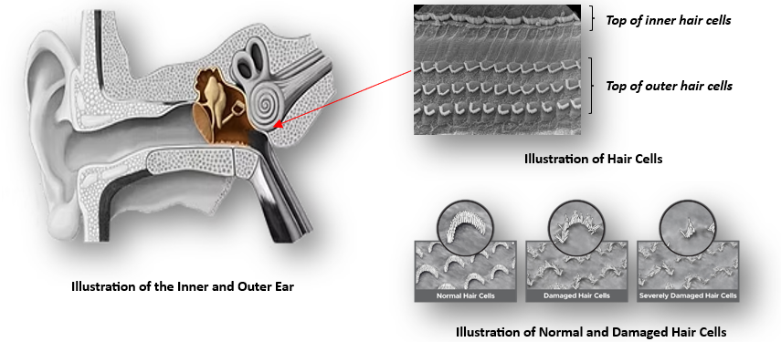
5.4 Process and Task Description
1. Overview
2. Work Environment and SEG Noise Exposure:
- [E.g. Receiving and Storage]
  - Operators
  - Mobile Equipment: Forklifts, loaders, and trucks in receiving and storage areas
- [E.g. Processing]
  - Production operators
  - Fixed Plant Equipment: Motors, conveyors, and vibrating machinery.
- [E.g. Maintenance]
  - Maintenance operators
  - Tools and Equipment: Pneumatic tools, grinders, and impact wrenches used during maintenance.
Employees in these areas are exposed to varying levels of noise during their shifts.
3. Noise Control Measures
A combination of noise control measures is utilized to manage noise exposure, including:
- Engineering Controls
- Administrative Control
- Training employees on noise hazards and safe work practices
- Personal Protective Equipment (PPE)
- A formal noise-induced hearing loss (NIHL) medical surveillance program, including baseline and periodic audiometric testing.
5.5 Historical data
A previous survey conducted revealed the following:
During
- 10 October 2025
Yesterday was a little late but it wasn't even the first one I was thinking of the lord and the same as I will not taught me that is the only
- 10 October 2025
Trees in my house in my house I don't have to go home but I'm just going home to work tomorrow morning to you and I can come back and see if I will get back from you and I can do that for Area One of drop and then you are not necessary to use it as a message from your bank and your bank is a lot more important to the company than your investment platform is not taught me that I have to pay you and you are very good to
5.6 Statutory Requirements
In terms of Noise Induced Hearing Loss Regulations, 2003, promulgated under the Occupational Health and Safety Act (OHS Act; Act 85 of 1993), no employer shall require or permit an employee to work in an environment in which he/she is exposed to an average, 8 Hour Equivalent Noise Rating Level, equal to or exceeding 85 dB(A), unless he implements suitable measures to protect the hearing of that employee.
Furthermore, in terms of the OHS Act, in general, and the Noise Induced Hearing Loss Regulations - 2003 more specifically, every employer has an obligation to assess/identify, evaluate and control all potential health hazards (including noise) to which his employees may be exposed.
In this regard, Noise Exposure Assessments are to be conducted every 2 years and Noise Surveys (Monitoring and Control Efficacy) to be conducted every 2 years by an Approved Inspection Authority (AIA).
6.0 | Survey Methodology
6.1 Instrumentation
Noise Zoning Measurements:
A calibrated Sound Level Meter (external calibration was performed by a SANAS accredited acoustic laboratory) was used to determine the average, equivalent, continuous noise rating levels; L Req,T. and 8-Hour equivalent noise rating levels (L Req,8h). This instrument was internally referenced before the survey was performed and was again checked after completion of the measurements using an Acoustic Calibrator.
Instrument | External Calibration Period
SLM - W63 (s/n: 51863 and 78705) | 06 January 2025 - 10 January 2025
Field calibrator - IS 30C (s/n: 456346) | 06 January 2025 - 10 January 2025
Personal Noise Dosimetry Measurements:
Calibrated (external calibration was performed by a SANAS accredited acoustic laboratory) noise dosimetry badges were used to determine the 8-Hour Equivalent Noise Rating Levels (L Ar,8h) for personal noise exposures.
These instruments were internally referenced before and checked after survey periods using an Acoustic Calibrator.
Instrument | External Calibration Period
Dosimetry badge - Copy from field sheet | Copy from field sheet (date from and date till) OR Maintenance Register
Type 2, Acoustic calibrator copy from field sheet | Copy from field sheet (date from and date till) OR Maintenance Register
(Add more rows for more pairs of dosimeters and calibrators)
Copies of the calibration certificates are attached under Section 10 of this report.
6.2 Measurement Methodology
The noise survey was performed in accordance with the legislated method for evaluating the workforce for hearing conservation purposes, as prescribed in SANS 10083 (latest version) “The measurement and assessment of occupational noise for hearing conservation purposes” as well as Gijima's work operation procedure (GIJ - OHES - WOP - 001). The formulas specified in the above-mentioned code were also used to convert the measured Noise Levels (L Req,T) to 8-Hour Equivalent Noise Rating Levels (L Req,8h), where applicable.
Table 6.2.1 Raw Risk Classification:
The noise rating levels reflected in the table below are used to assess the risks of worker exposure to noise and establish the action required for the various levels of noise exposure.
Average Noise Rating Level dB(A) | Raw Risk Classification | Required Actions
<82 | Low Risk of NIHL | - No action required
≥ 82 - <85 | Moderate Risk of NIHL | - Implement Hearing Conservation Programme  - Conduct Medical Surveillance  - Apply hearing protection devices
≥ 85 - <105 | High Risk of NIHL | - Demarcate area as a noise zone  - Hierarchy of Control  - Ensure regular Occupational Hygiene Monitoring and Medical Surveillance, as per requirements under the Noise Induced Hearing Loss Regulations (2003) and SANS 10083 (latest version).
≥ 105 | Very High Risk of NIHL
Legend: NIHL Noise-Induced Hearing Loss
6.3 Strategy
6.3.1 Noise zoning survey
The noise survey strategy was in accordance with the legislated strategy for area evaluations for noise zoning purposes, as prescribed in SANS 10083 (latest version) The measurement and assessment of occupational noise for hearing conservation purposes as well as Gijima's work operation procedure (GIJ - OHES - WOP - 001).
Noise measurements were taken over long enough periods and during normal working conditions, to evaluate noise rating levels as near as possible to representative exposure levels. At least three positions were selected which are representative of the work area noise characteristics, alternatively measurement positions were determined by selecting representative workstations. Each individual measurement was taken over a representative period of time to ensure that all possible variations in noise generation in the area i.e. all possible noise sources, and fluctuations or cycles were included in the measurement value. Measurements were taken over shorter periods of time where there were no/ limited variations in the noise generation i.e. the noise generated is constant/the same for the whole shift or duration of a specific activity (i.e. operating a specific piece of machinery).
6.3.2. Personal noise dosimetry measurements
For a given SEG the aim is to identify the highest exposed individual, in accordance with OESSM Strategy 1, a framework developed by the National Institute for Occupational Safety and Health (NIOSH) which provides guidance on creating a statistically valid sampling plan to evaluate worker exposure to hazardous substances or stressors in the workplace.
Noise dosimetry measurements were performed over a period considered representative of the individual's entire work shift (at least 80% of shift duration).
6.4 Deviations, Uncertainties and Limitations
Gijima OHES strives to comply with best practice and to strictly adhere to the methods and procedures as contained in its Quality Management System.
Due to logistical constraints, not all of the samples covered 80% of the work shift. No other deviations or uncertainties occurred during the execution of the methods and sampling protocols, as a result of circumstances beyond the control of Gijima OHES.
The following deviations and uncertainties applied during this survey:
Description |  |  | Reason and Impact
Deviations
Methodology |  |  | Every day I have been doing
Strategy |  |  | Well that's what I want for a relationship with
Uncertainty
Methodology |  |  | Yesterday you are not going through my country and pressure
Strategy |  |  | Historical in my country as I am a
 | 7.0 | Results and Discussion
7.1 Results
The following table/s reflect the results and findings of a Noise Survey, conducted at Client Two, Tzaneen on 10 October 2025 - 18 October 2025.

The below legend that describes Noise Exposure Risk Levels apply to all tables of results below.

Value 8-hour equivalent Noise Rating Level <Action Level of 82 dB(A)
Value 8-hour equivalent Noise Rating Level ≥ the Action Level of 82 dB(A), but < the statutory limit of 85 dB(A)
Value 8-hour equivalent Noise Rating Level ≥ the statutory limit of 85 dB(A) but <105 dB(A)
Value 8-hour equivalent Noise Rating Level ≥ 105 dB(A)
TABLE 7.1.1 NOISE ZONING RESULTS: Area 1:Area 1.2:
No |  |  | Area / Location / Activity |  | Measurement Position |  |  | Measured Noise Rating Level in dB(A) |  | 8-Hour Equivalent Noise Rating Level (LReq,8h) |  |  | Raw Risk Classification of NIHL |  |  | Discussion
Area 1.1
1.1 |  |  | Area 1.1 |  | A  B  C  D |  |  | 78.98  76.88  59.78  44.76 |  | 75.08 |  |  | Low Risk |  |  | - Employees work 8 hours shifts and spend up to 6 hours in the respective areas.  - The primary noise sources and their nature of noise during normal working activities include:  - Sound A-Cyclic-no pattern
 | Evaluation Results:
- Normal operating conditions prevailed on the day of the survey.
Engineering Controls:
- Controls
- Administrative Controls:
- Is the area demarcated as a noise zone? No
- Is the area correctly demarcated as a noise zone? No
- Have the following administrative controls been selected ?
  - Training: No
  - Reduced exposure time: No
  - Rotation procedures: No
  - Written procedures: No
  - Medical surveillance: Yes
- Is the area demarcated as a noise zone? No
- Is the area correctly demarcated as a noise zone? No
- Have the following administrative controls been selected ?
  - Training: No
  - Reduced exposure time: No
  - Rotation procedures: No
  - Written procedures: No
  - Medical surveillance: Yes
Hearing Protection devices: Employees are issued with the following hearing protective devices (HPDs):
- Disposable, Sony with SNR of 44.
- Have Employees in this area received training in the correct use of HPD? YesYes
- , with of .
- Have Employees in this area received training in the correct use of HPD? 0
- These HPDs probably (provide/do not provide) adequate protection against the noise rating levels in this area.
  - Insert manually
Prohibited Activities:
- Have employees engaged in prohibited activities? No
Concomitant Exposures:
- Are employees exposed to Concomitant Exposures? No
TABLE 7.1.2 NOISE ZONING RESULTS: Area 1:Area 1.2:
No |  |  |  | Area / Location / Activity |  |  | Measurement Position |  | Measured Noise Rating Level in dB(A) |  |  | 8-Hour Equivalent Noise Rating Level (LReq,8h) |  |  | Raw Risk Classification of NIHL |  |  | Discussion
Area 1.2.1
1.201 |  |  |  | Area 1.2.1 |  |  | A  B |  | 45.87  78.55 |  |  | 75.54 |  |  | Low Risk |  |  | - Employees work 8 hours shifts and spend up to 5 hours in the respective areas.  - The primary noise sources and their nature of noise during normal working activities include:  - Sound B-Impulse
 | Evaluation Results:
- Normal operating conditions prevailed on the day of the survey.
Engineering Controls:
- Controls 2
Administrative Controls:
- Is the area demarcated as a noise zone? No
- Is the area correctly demarcated as a noise zone? No
- Have the following administrative controls been selected ?
  - Training: No
  - Reduced exposure time: No
  - Rotation procedures: Yes
  - Written procedures: Yes
  - Medical surveillance: No
Hearing Protection devices: Employees are issued with the following hearing protective devices (HPDs):
- Disposable, Nokia with SNR of 89,88.
- Have Employees in this area received training in the correct use of HPD? YesYes
- , with of .
- Have Employees in this area received training in the correct use of HPD? 0
- These HPDs probably (provide/do not provide) adequate protection against the noise rating levels in this area.
  - Insert manually
Prohibited Activities:
- Have employees engaged in prohibited activities? No
Concomitant Exposures:
- Are employees exposed to Concomitant Exposures? No
TABLE 7.1.3 NOISE ZONING RESULTS: Area 2
No |  | Area / Location / Activity |  |  |  | Measurement Position |  | Measured Noise Rating Level in dB(A) |  |  | 8-Hour Equivalent Noise Rating Level (LReq,8h) |  |  | Raw Risk Classification of NIHL |  |  | Discussion
Area 2
2 |  | Area 2 |  |  |  | A  B |  | 55  55 |  |  | 55.00 |  |  | Low Risk |  |  | - Employees work 8 hours shifts and spend up to 6 hours in the respective areas.  - The primary noise sources and their nature of noise during normal working activities include:  - Sound C-Impulse
 | Evaluation Results:
- Normal operating conditions prevailed on the day of the survey.
Engineering Controls:
- Controls 3
Administrative Controls:
- Is the area demarcated as a noise zone? No
- Is the area correctly demarcated as a noise zone? No
- Have the following administrative controls been selected ?
  - Training: Yes
  - Reduced exposure time: No
  - Rotation procedures: No
  - Written procedures: No
  - Medical surveillance: No
Hearing Protection devices: Employees are issued with the following hearing protective devices (HPDs):
- Disposable, Kia with NRR of 78,90.
- Have Employees in this area received training in the correct use of HPD? YesYes
- , with of .
- Have Employees in this area received training in the correct use of HPD? 0
- These HPDs probably (provide/do not provide) adequate protection against the noise rating levels in this area.
  - Insert manually
Prohibited Activities:
- Have employees engaged in prohibited activities? No
Concomitant Exposures:
- Are employees exposed to Concomitant Exposures? No
Survey Measurement Attachment - Screenshot_20250825_162339_Samsung Internet.jpg
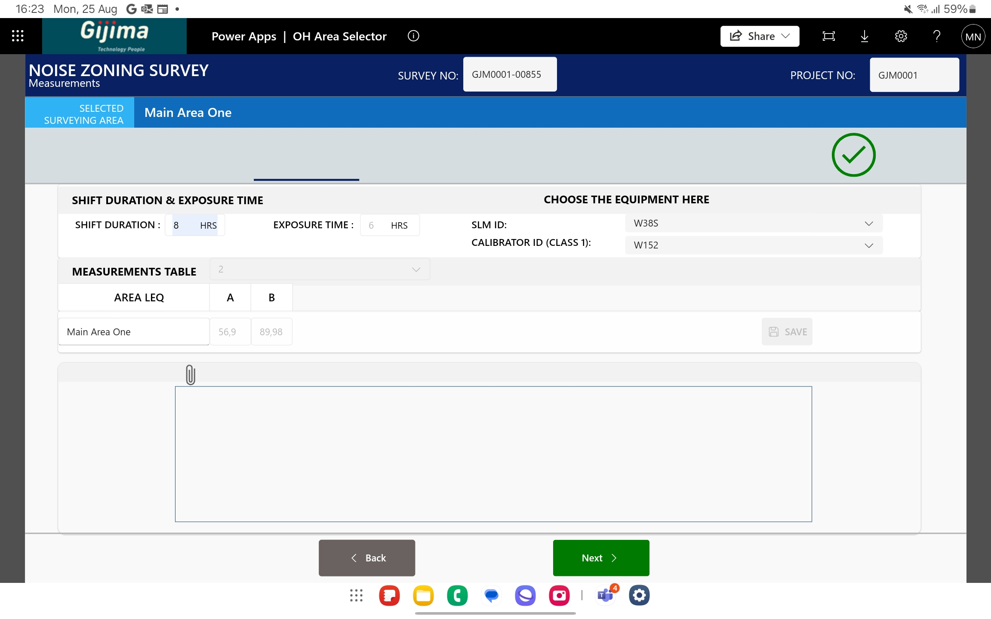
TABLE 7.2: PERSONAL NOISE DOSIMETRY RESULTS AT (Insert main Area name here)
No | Employee Name / Occupation | Work Activities | Average Noise Rating Level (L Req,8h ) | Raw Risk Classification of NIHL | Discussion
1. (Insert sub-area name here from field sheet)
1.1 | Insert from field sheet | Insert from field sheet | (Insert calculation Sheet Value 2 here -text color according to rating value (g,a,r,m)) | (Insert Risk Level according to Matrix) and shade cell accordingly (g,a,r,m)) | - Employees work (insert duration in hrs from field sheet ) hour shifts and spend up to ( insert in hrs from field sheet)  - The noise is of a ( insert from field sheet) nature.  - The primary noise sources during normal working activities include:  - ( Insert from field sheet )  - ………
2. (Insert sub-area name here from field sheet)
2.1 | Insert from field sheet | Insert from field sheet | (Insert calculation Sheet Value 2 here -text color according to rating value (g,a,r,m)) | (Insert Risk Level according to Matrix) and shade cell accordingly (g,a,r,m)) | - Employees work (insert duration in hrs from field sheet) hour shifts and spend up to (insert in hrs from field sheet)  - The noise is of a (insert from field sheet) nature.  - The primary noise sources during normal working activities include:  - (Insert from field sheet)  - ………
2.2 | Insert from field sheet | Insert from field sheet | (Insert calculation Sheet Value 2 here -text color according to rating value (g,a,r,m)) | (Insert Risk Level according to Matrix) and shade cell accordingly (g,a,r,m))
Evaluation
Results:
- Normal operating conditions prevailed /did not prevail on the day of the survey (elaborate as needed).
- During conditions on the day, the average 8-hour noise rating exposure level for the following employees exceed the statutory limit:
  - (Insert from noise calculation sheets)
- The risk that the above-mentioned employees may develop Noise Induced Hearing Loss is High
- During conditions on the day, the average 8-hour noise rating exposure level for the following employees exceed 105dB(A):
  - (Insert from noise calculation sheets)
- The risk that the above-mentioned employees may develop Noise Induced Hearing Loss is Very High
Engineering Controls:
- There are ( Insert from field sheet ) in place for the effective reduction of noise levels.
Administrative Controls:
- Employees ( insert from field sheet ; are/are not) subjected to an audiometric testing program (pre-employment, annual and exit audiometry), in accordance with Regulation 8 of the NIHL Regulations (2003) promulgated in terms of the OHS Act, 1993 (Act 85 of 1993).
Hearing Protection devices:
- Employees are issued with the following hearing protective devices (HPDs):
- (Insert from field sheet; type) from (insert form field sheet; manufacturer) with (insert from field sheet; NRR/SNR) of (insert value from field sheet).
- These HPDs probably (provide/do not provide) adequate protection against the noise rating levels in this area.
Prohibited Activities:
- Employees did not engage in prohibited activities
- Employees engaged in the following prohibited activities:
- (insert from field sheet)
Concomitant Exposures:
- Employees are exposed to ototoxic substances as well as noise rating levels in excess of 82dB(A), namely:
- ( Name of substance Insert from field sheet), at(insert sub-sub areas from field sheet )
- Employees in the following are exposed to vibration and noise rating levels in excess of 82dB(A):
- (insert sub-sub areas from field sheet)
TABLE 7.3: MOBILE NOISE SOURCE RESULTS AT (Insert main Area name here)
No. | Area/ Location/ Activity | Measurement Position | Measured Noise Rating Level in dB(A) | 8-Hour Equivalent Noise Rating Level (L Req,8h ) | Raw Risk Classification for NIHL | Evaluation of Results
- (Insert vehicle name and model from field sheet here)
1.1 | Operator ear - Idle speed Insert from field sheet | Operator ear | (Insert calculation Sheet Value 1 here) | (Insert calculation Sheet Value 2 here -text color according to rating value (g,a,r,m)) | (Insert Risk Level according to Matrix) and shade cell accordingly (g,a,r,m)) | - The (insert vehicle type from field sheet) is (demarcated/not demarcated) as a mobile source with symbolic safety signage.  - The noise rating levels generated by the ( insert vehicle details from field sheet) when idling and when operating were <82.0 dB(A).  - The reverse alarm generated an average noise rating level in excess of 85.0 dB(A) at the operator ear position .
1.1 | Operator ear -engine at operating revolutions Insert from field sheet | Operator ear | (Insert calculation Sheet Value 1 here)
1.1 | Operator ear -reverse warning alarm sounding Insert from field sheet | Operator ear | (Insert calculation Sheet Value 1 here) | (Insert calculation Sheet Value 2 here -text color according to rating value (g,a,r,m)) | (Insert Risk Level according to Matrix) and shade cell accordingly (g,a,r,m))
- (Insert vehicle name and model from field sheet here)
2.1 | Operator ear - Idle speed Insert from field sheet |  | (Insert calculation Sheet Value 1 here) | (Insert calculation Sheet Value 2 here -text color according to rating value (g,a,r,m)) | (Insert Risk Level according to Matrix) and shade cell accordingly (g,a,r,m)) | - The (insert vehicle type from field sheet) is not demarcated as a mobile noise source by symbolic safety signage to indicate the mandatory use of HPDs.  - The average noise rating level generated by the (insert vehicle details from field sheet) when idling was <82.0 dB(A).  - The average noise rating level generated by the (insert vehicle details from field sheet) at operator ear position during typical operations was >82.0 dB(A) but below 85.0 dB(A).  - The reverse warning alarm generated an average noise rating levels below the action level of 82.0 dB(A) at the operator ear position.
2.1 | Operator ear -engine at operating revolutions Insert from field sheet |  | (Insert calculation Sheet Value 1 here ) | (Insert calculation Sheet Value 2 here -text color according to rating value (g,a,r,m)) | (Insert Risk Level according to Matrix) and shade cell accordingly (g,a,r,m))
Evaluation
Results:
- Normal operating conditions prevailed /did not prevail on the day of the survey (elaborate as needed).
- During conditions on the day, the average 8-hour noise rating exposure level liberated by the following equipment exceed the statutory limit:
  - (Insert from noise calculation sheets)
- The risk that operators of the above-mentioned equipment may develop Noise Induced Hearing Loss is High.
- During conditions on the day, the average 8-hour noise rating exposure level for the following employees exceed 105dB(A):
  - (Insert from noise calculation sheets)
- The risk that the above-mentioned employees may develop Noise Induced Hearing Loss is Very High
Engineering Controls:
- There are ( Insert from field sheet ) in place for the effective reduction of noise levels.
Administrative Controls:
- (insert equipment-specific details here) (field sheet and manually insert)
Hearing Protection devices:
- Employees are issued with the following hearing protective devices (HPDs):
- (Insert from field sheet ; type) from (insert form field sheet ; manufacturer) with (insert from field sheet ; NRR/SNR) of (insert value from field sheet).
- These HPDs probably (provide/do not provide ) adequate protection against the noise rating levels in this area.
Prohibited Activities:
- Employees did not engage in prohibited activities
- Employees engaged in the following prohibited activities:
- (insert from field sheet)
Concomitant Exposures:
- Employees are exposed to ototoxic substances as well as noise rating levels in excess of 82dB(A), namely:
- (Name of substance Insert from field sheet), at (insert sub-sub areas from field sheet)
- Operators of the following equipment are exposed to vibration and noise rating levels in excess of 82dB(A):
- (insert sub-sub areas from field sheet).
TABLE 7.4: NOISY EQUIPMENT RESULTS AT (Insert main Area name here)
No. | Area/ Location/ Activity | Measurement Position | Measured Noise Rating Level in dB(A) | 8-Hour Equivalent Noise Rating Level (L Req,8h ) | Raw Risk Classification for NIHL | Noise Sources and Characteristics
- (Insert Sub Area name here) (Field sheet)
1.1 | Noise rating levels at the (insert sub-sub area details here -from field sheet) | A | (Insert calculation Sheet Value 1 here) | (Insert calculation Sheet Value 2 here -text color according to rating value (g,a,r,m)) | (Insert Risk Level according to Matrix) and shade cell accordingly (g,a,r,m)) | - Employees work (insert duration in hrs from field sheet) hour shifts and spend up to (insert in hrs from field sheet)  - The noise is of a (insert from field sheet) nature.  - The primary noise sources include (insert from field sheet):  - …  - …  - …
- NOISY TOOLS/ACTIVITIES
2.1 | (insert equipment details here - from field sheet) | Operator ear position | (Insert calculation Sheet Value 1 here) | (Insert calculation Sheet Value 2 here -text color according to rating value (g,a,r,m)) | (Insert Risk Level according to Matrix) and shade cell accordingly (g,a,r,m))
2.2 |  | Operator ear position
2.3 |  | Operator ear position
2.4 |  | Operator ear position
2.5 |  | Operator ear position
2.6 |  | Operator ear position
(Table continues on the following page)
Evaluation
Results:
- Normal operating conditions prevailed /did not prevail on the day of the survey (elaborate as needed).
- During conditions on the day, the average 8-hour noise rating exposure level liberated by the following equipment exceed the statutory limit:
- (Insert from noise calculation sheets)
- The risk that operators of the above-mentioned equipment may develop Noise Induced Hearing Loss is High.
- During conditions on the day, the average 8-hour noise rating exposure level for the following employees exceed 105dB(A):
- (Insert from noise calculation sheets)
- The risk that the above-mentioned employees may develop Noise Induced Hearing Loss is Very High
Engineering Controls:
- There are (Insert from field sheet) in place for the effective reduction of noise levels.
Administrative Controls:
- ( Insert equipment-specific details here) Field sheet and/ or Manually
Hearing Protection devices:
- Employees are issued with the following hearing protective devices (HPDs):
- (Insert from field sheet ; type) from (insert form field sheet; manufacturer) with (insert from field sheet ; NRR/SNR) of (insert value from field sheet).
- These HPDs probably (provide/do not provide) adequate protection against the noise rating levels in this area.
Prohibited Activities:
- Employees did not engage in prohibited activities
- Employees engaged in the following prohibited activities:
- (Insert from field sheet)
Concomitant Exposures:
- Employees are exposed to ototoxic substances as well as noise rating levels in excess of 82dB(A), namely:
- ( Name of substance Insert from field sheet), at (insert sub-sub areas from field sheet)
- Operators of the following equipment are exposed to vibration and noise rating levels in excess of 82dB(A):
- (insert sub-sub areas from field sheet).

8.0 | Recommendations
8.1. Engineering Control Measures
Noise Zoning
Improvement of Current Control Measures
Insert manually according to evaluations in results tables
Recommended new Engineering Control Measures
Insert manually
Personal Noise Exposure
Improvement of Current Control Measures
Insert manually according to evaluations in results tables
Recommended new Engineering Control Measures
Insert manually
Mobile Noise sources
Improvement of Current Control Measures
Insert manually according to evaluations in results tables
Recommended new Engineering Control Measures
Insert manually
Noisy Equipment
Improvement of Current Control Measures
Insert manually according to evaluations in results tables
Recommended new Engineering Control Measures
Insert manually
8.2. Administrative Control Measures
Areas currently correctly demarcated as noise zones:
- Insert manually according to evaluations in results tables
The following areas need to be demarcated as noise zones:
- Insert according to evaluations in results tables
Symbolic safety signage conforming to SANS 1186 (MV4) must be posted in the noise zones and on the identified equipment/tools to warn employees and operators of the noise hazards and of the need to make compulsory use of approved HPDs.  - All previously identified noise zones should remain demarcated as such.  - Noise zone symbolic safety signage must indicate that the wearing of HPDs is compulsory, irrespective of the duration of entry into the demarcated Noise Zones or the duration of use of noisy tools or mobile noise sources. The use of HPDs in these areas must be enforced. | 
- Employees who engage in the following activities must be issued with both ear plugs and earmuffs for combined, simultaneous use. The HPDs must have a minimum NRR- (insert from calculation sheet):
    - Insert from Results Tables
Appropriate symbolic safety signage must be posted up in these areas -see below example
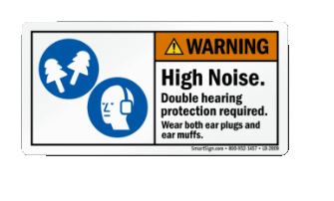
- Workers on site must be instructed to limit their exposure to excessive noise as far as reasonably practicable by moving away from noise sources when these are in active operation.
- All moving machinery must be subject to regular maintenance, servicing and lubrication to prevent unnecessary noise generation due to the vibration of loose parts/equipment. Ensure that all machine parts, grids, hatches etc, are properly closed and secured (tight fit) to reduce any rattling or vibrating noise.
8.3. Hearing Protective Devices (HPDs) Improvement of Current Control Measures
- Insert manually according to evaluations in results tables
Employees are issued with the following HPDs:
- Insert according to evaluations in results tables
Workers who engage in tasks exceeding a noise level of 105 dB(A) must be issued with both earplugs and earmuffs for combined, simultaneous use -i.e. use of double hearing protection. The selected HPDs must have a minimum attenuation factor (NRR) of at least (insert from calculation sheet) prevent/reduce bone conduction of noise to the ear canal and help prevent noise related nerve damage within the ear itself. Fitment Effectiveness of HPDs is dependent on the correct donning thereof, and therefore it is important that employer ensures that employees are informed concerning the correct use of HPD's. Individualised selection and fitment of HPD's must be conducted by a competent person, i.e. an OHP or other suitably competent person, preferably in conjunction with the Risk Based Medical Examinations (in this case Audiometric Testing). This examination incorporates an HPD compatibility assessment, the findings of which must be considered during selection and fitment, as should the selection criteria. Accordingly, and as stated previously, selection, fitment and instruction with regard to HPD's should be addressed at the time of the audiometric test. The competent person conducting HPD fittings must be satisfied that the employee is well capable of inserting or otherwise applying the devices selected, so as to obtain a level of protection that is adequate for the noise environment where he or she will work.
Fitment of re-usable earplugs
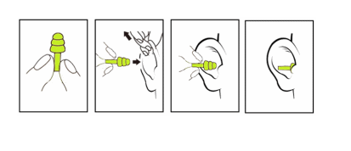
Fitment of disposable earplugs
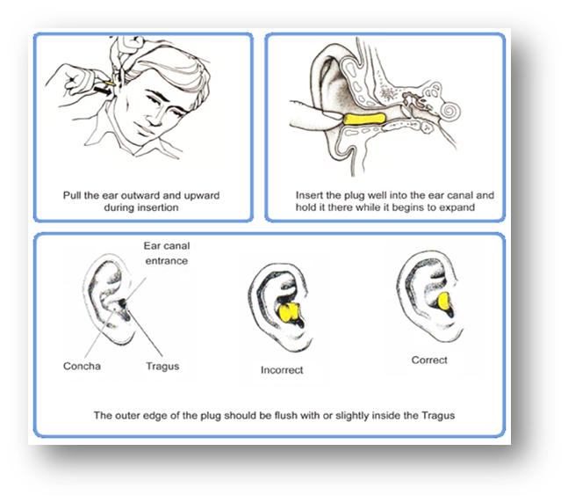
Fitment of earmuffs
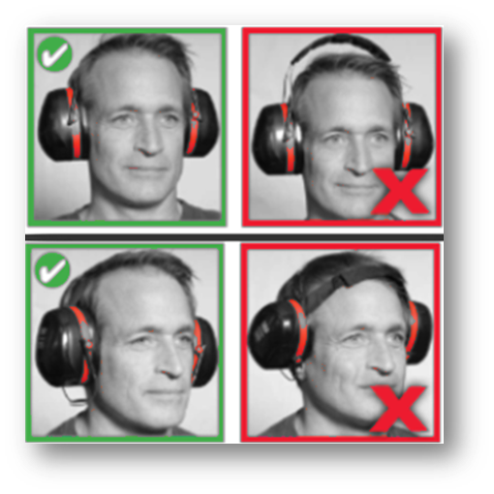
Fitment of custom-mold earplugs (wearer-specific)
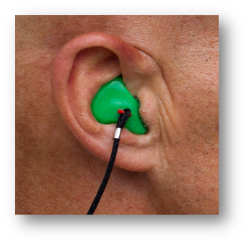
8.4. Medical Surveillance
A medical surveillance programme (entry, periodic and exit medicals) is (in place/is not in place), which is in accordance with Regulation 8 of the NIHL Regulations (2003) promulgated in terms of the OHS Act, 1993 (Act 85 of 1993). Audiometric testing must meet the following criteria: (1) Medical Surveillance (in this case, Audiometric Testing) may only be conducted by a certified, competent person. Meaning: a person registered in terms of the Health Professions Act, 1974 (Act 56 of 1974), with the Health Professions Council of South Africa in any of the following three categories:
- Otorhinolaryngologist (ear, nose and throat specialist);
- Speech therapist and audiologist;
- Occupational medicine practitioner or
a person with a qualification in audiometric techniques obtained from an institution registered with the South African Qualification Authority or any of its structures in terms of the South African Qualifications Authority Act, 1995 (Act 58 of 1995), and registered with the South African Society for Occupational Health Nursing (SASOHN); (2) All persons that are potentially excessively exposed to noise, or could in future be excessively exposed to noise (i.e., new employees, or those regularly operating noisy machinery, their assistants, and persons regularly working in the noise zones), should be subjected to an audiometric testing programme, as contemplated in Regulation 8 of the Noise Induced hearing Loss Regulations and SANS 10083 (latest version), that includes: (a) a baseline audiogram, which is recorded—
- in the case of a new employee, before the employee commences employment or within 30 days of commencement of such employment; or
- in the case of all other employees in the employment of the employer, before 16 November 2003; and
- in accordance with the requirements of Instruction No. 171: Provided that the baseline audiogram conducted in terms of that instruction applies to that employee for the rest of his working career;
(b) a periodic audiogram which is conducted in accordance with SANS 10083 (latest version) and which, during the first three years of employment, is obtained at least annually and thereafter at intervals which may be extended to a maximum period of two years if no referral threshold shift is evident; with the provision that where employees working in or are required to enter a noise zone, where the noise rating level is ≥105dB(A), testing must be conducted at 6 monthly intervals until it is established that no referral threshold shift is evident and thereafter the interval between tests may be extended to a maximum interval of one year. The following employees/occupations must undergo audiometric testing every six months:
- Insert from results table Employee Name / Occupation if Results table indicate a result of ( ≥ 105dB(A)- (
- …
- …
(c) consists of an exit audiogram, conducted in accordance with SANS 10083 (latest version), which is obtained for every employee whose employment is terminated or who is permanently transferred to another workplace in respect of which audiometric tests are not required: Provided that an audiogram conducted within six months prior to termination of employment or transfer shall meet this requirement; and (d) is performed by a competent person: Provided that if it is impossible for the competent person to establish a baseline audiogram for an employee as contemplated in paragraph (a,), the employee must be referred to an audiologist who may establish baseline-hearing levels by using other techniques, such as speech reception thresholds.(3) An employer shall ensure that—(a) copies of the audiograms contemplated in subparagraphs (2) (a), (b) and (c) are entered into the employee's record of medical surveillance.(b) a copy of each audiogram contemplated in subparagraphs (2) (a) and (c) is given to the employee when he or she leaves the employment of that employer.(c) new employees provide him or her with their baseline audiograms, exit audiograms or most recent audiograms and the percentage of loss of hearing calculated in accordance with instruction No. 171; and(d) in the case of an employee whose percentage loss of hearing has deteriorated by 10% or more since the baseline audiogram was recorded or an employee for whom no baseline audiogram is available but who has a 10% or more loss of hearing that is not due to medical causes and has been confirmed by a repeat audiogram—
- the relevant health and safety committee or the relevant health and safety representative is informed of the finding.
- the employee is refrained and re-instructed.
- noise control measures are reassessed; and
- such hearing loss is reported to the provincial director, on form WCL1/2, as contemplated in Regulation 6 of the General Administrative Regulations, 2003.
8.5. Training
Improvement of Current Control Measures
The employees in the following areas need training in the proper use of prescribed HPDs:
• Insert according to evaluations in results tables
The employees engaged in the following occupations need training in the proper use of prescribed HPDs:
• Insert according to evaluations in results tables
Such training must include information on workplace noise levels, the correct fitment of HPDs (see fitment and illustration under Section 8.3), HPD attenuation ratings (noise reduction ratings), correct storage of HPDs, HPD maintenance and replacement as well as the aspects detailed in Section 8.3 of this report.
After consultation with the health and safety committee and the health and safety representative, designated for that workplace, a Training Program must be established for all employees who may be exposed to noise at or above the Noise Rating Limit that incorporates the following:
- the content and scope of the NIHL Regulations.
- the potential sources of exposure to noise in the specific work environment.
- the potential risks to health and safety caused by exposure to noise.
- the measures taken by the employer to protect an employee against the detrimental effects of exposure to noise.
- the precautions to be taken by the employees to protect themselves against the health risks associated with the exposure, including the wearing and use of earplugs and earmuffs.
- the necessity, correct use, maintenance and limitations of hearing protectors, facilities and engineering control measures provided.
- the assessment of exposure, the purpose of noise monitoring, the necessity for medical surveillance and the long-term benefits and limitations of undergoing such surveillance.
- the Noise Rating Limit for hearing conservation and its meaning.
- the procedures for reporting, correcting, and replacing defective personal hearing protectors and for engineering noise control measures.
Records of training given to an employee, as detailed above, must be kept for as long as the employee remains employed at the workplace in which he/she is being exposed to noise. Such training must also be conducted prior to the placement of the relevant employee. Refresher training must be conducted annually or at intervals that may be recommended by the health and safety committee and the health and safety representative. The above-mentioned training must be provided by a person who is competent to do so and who has adequate personal practical experience and theoretical knowledge of all aspects of the work carried out by the employee. All visitors or persons other than employees who may be affected by noise exposure at the workplace must also be given adequate information, instruction and training and must be provided with at least disposable hearing protectors.
8.6. Records
Records of assessments, noise monitoring (i.e. this Report) and all medical surveillance records, including the baseline audiogram of every employee, must be kept for a minimum period of 40 years. If the employer ceases activities, his personal records must be handed over or forwarded by registered post, to the relevant provincial director, provided that those records shall contain at least the following information:
- Each employee's surname, forenames, gender, date of birth, name of spouse or closest relative and, where available, permanent address and postal code.
- a record of the types of work carried out that caused noise exposure and, where relevant, their location, with starting and finishing dates and with average duration of exposure in hours per week.
- a record of any previous work-related noise exposure prior to an employee's current employment.
- the dates of medical surveillance and results of all audiograms.
Records of training given to an employee, as detailed above, must be kept for as long as the employee remains employed at the workplace in which he/she is being exposed to noise.
8.7. Workplace monitoring
Noise exposure assessments and/or measurements must be repeated by an Approved Inspection Authority (AIA) at intervals not exceeding two years or as soon as any changes occur that could result in a change in or redistribution of noise levels, or if there is any suspicion that the current/previous assessment is no longer valid (upon acquisition of new machinery/equipment, relocation of potentially noisy equipment, etc.) Furthermore, the Department of Employment and Labour requires other Occupational Hygiene Inspections to be conducted for the facility to be fully legally compliant (in terms of current and pending legislative requirements). These include (but are not limited to): Choose applicable or add other surveys deemed necessary.
- Hazardous Chemical Agents Exposure Survey (HCA Regulations, 2021)
- sbestos Inventory and Risk Assessment (Asbestos Abatement Regulations, 2020)
- Artificial Illumination Survey (Environmental Regulations for Workplaces, 2003)
- Indoor Air Quality Survey (Environmental Regulations for Workplaces, 2003)
- Hazardous Biological Agents Surveys (HBA Regulations, 2022)
- Ergonomics Assessments (Ergonomics Regulations, 2019)
- Vibration Surveys (Occupational Health and Safety Act, 85 of 1993, and others)
You are welcome to contact Gijima OHES (an Approved Inspection Authority) for professional assistance with the above.
9.0 | Conclusion
Based on the outcomes of the noise survey performed at (insert client name and site name here- same as in Main findings Section of this report ) in (month-year of survey - same as in Main findings Section of this report ), the following was concluded:
Several areas were identified or confirmed as noise zones and specific individual employees being identified or confirmed as being excessively exposed to noise:
Areas Identified or Confirmed as Noise Zoning: Information same as in Main findings Section of this report)
- X Number of Areas were identified as “new” Noise Zones
- Y Number of Areas were confirmed as previously Identified Noise Zones
- Z Number of Areas previously identified as Noise Zones no longer are considered to be Noise Zones.
Individuals subjected to Noise Dosimetry found to be or confirmed to be excessively exposed to noise: Information same as in Main findings Section of this report)
- X Number of Occupations were identified as “new” occupations that are excessively exposed
- Y Number of Occupations were identified as previously identified occupations that are excessively exposed
- Z Number of Areas previously identified as excessively exposed occupations are no longer excessively exposed.
Another Objective of the survey was to determine the efficacy of hearing conservation measures applied. These details follow below. Evaluation of Control Measures: Information same as in Main findings Section of this report) Engineering Control Measures:
- In general, in terms of specification (Noise Reduction) , the XXXX provided (are/are not) capable of supplying effective reduction of noise levels.
Administrative Control Measures:
- In general, in terms of specification (Noise Reduction) , the XXXX provided (are/are not) capable of supplying effective reduction of noise levels.
Hearing Protective Devices (HPDs):
- In general, in terms of specification (Noise Reduction), the HDPs provided (are/are not) capable of providing adequate protection
- In general, employee (applied/did not apply) HPDs correctly
Recommendations
(Information same as in Main findings Section of this report)
In order to improve compliance with the Noise Induced Hearing Loss Regulations, there must be a strong focus on (choose and elaborate on any of the topics below and add as deemed necessary):
• Separation of areas producing excessive noise levels and areas unnecessarily affected by noise, such as (insert areas concerned) • Demarcation of newly identified noise zones
• Provision of effective Hearing Protective Devices to all employees working in Noise zones
• Provision of effective Hearing Protective Devices to all individuals identified as being excessively exposed to noise or engaging in tasks or activities producing excessive noise levels
• Training of employees in the correct way the HPDs must be applied
• Regular audiometric testing of all employees working in Noise zones and/or individuals identified as being excessively exposed to noise or engaging in tasks resulting in exposure to excessive noise levels
• Adopting a “Buy Quiet” procurement policy
• Please refer to Section 8 (Recommendations) of this report for details pertaining to corrective actions.
10.0 | Certificates
The following certificates must be attached to the report:
- Department of Employment and Labour registration certificate
- SANAS
- Current Equipment calibration certificates
- Current SAIOH registration certificate of Inspector and Technical Signatory
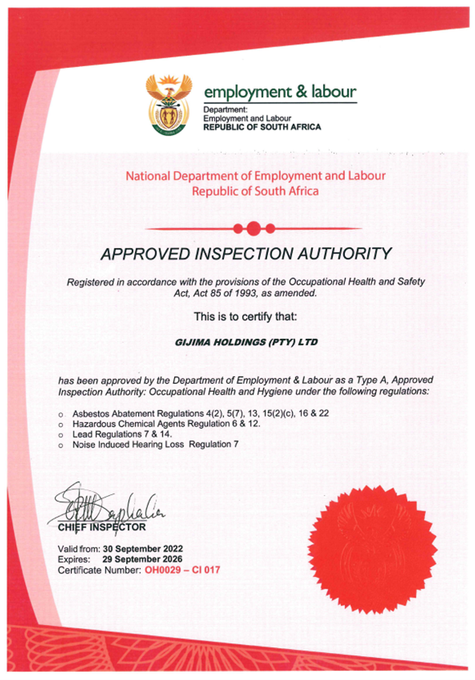
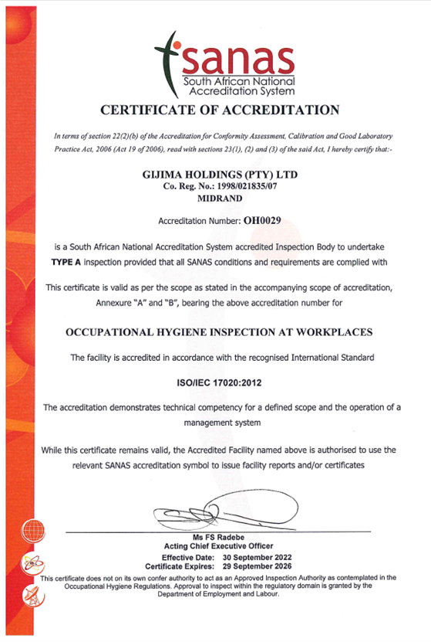
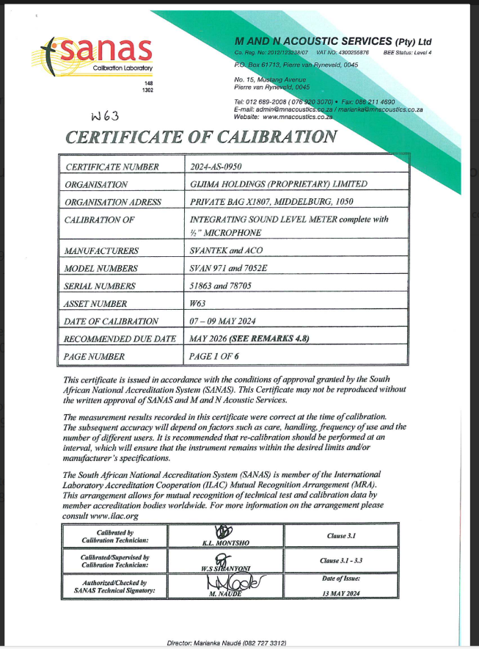
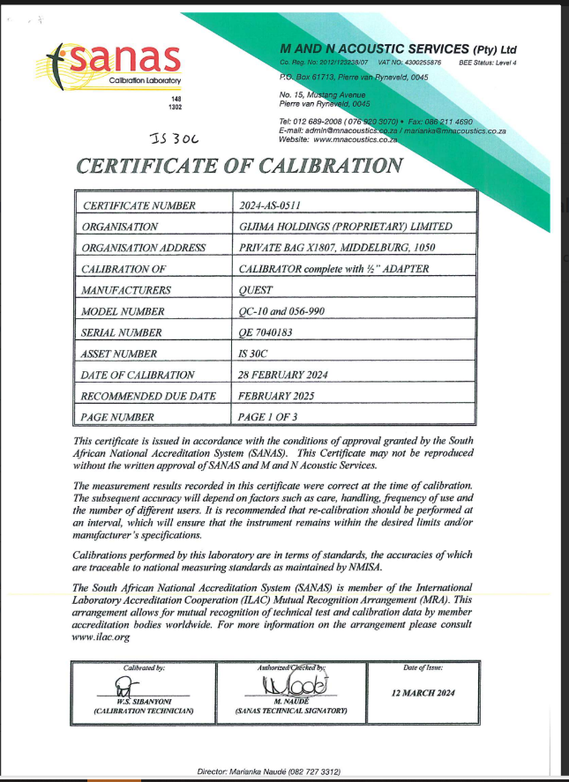
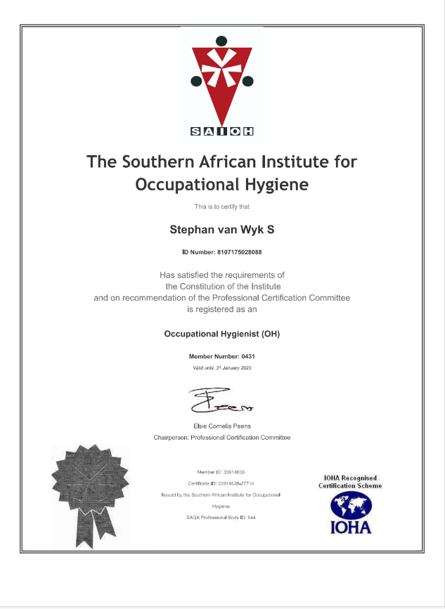
11.0 | Signature Page
The undersigned herewith declare that the requirements as mentioned in the statement page were adhered to and that the contents of this report comply with the Gijima OHES's Quality Policies and with the requirements of the Department of Employment and Labour for Approved Inspection Authorities/Inspection Bodies.
GIJIMA OCCUPATIONAL HYGIENE AND ENVIRONMENTAL SERVICE
Private Bag X1807, Middelburg, 1050 | Tel: 013 591 3903/3916 | Fax: 086 622 9242
E-mail: OHES@gijima.com
K. TSHIKARE  (Report Author Signature)  REGISTERED OCCUPATIONAL HYGIENE ASSISTANT  (S.A.I.O.H. Membership No. 2127) | M. KEYTER  (Technical Signatory Signature Report Issue Date)  REGISTERED OCCUPATIONAL HYGIENIST  (S.A.I.O.H. Membership No. 1425)

